Dynamic Film Reranker
A website that dynamically displays and reranks the IMDb Top 250 Films based on similarity to user-selected movies.
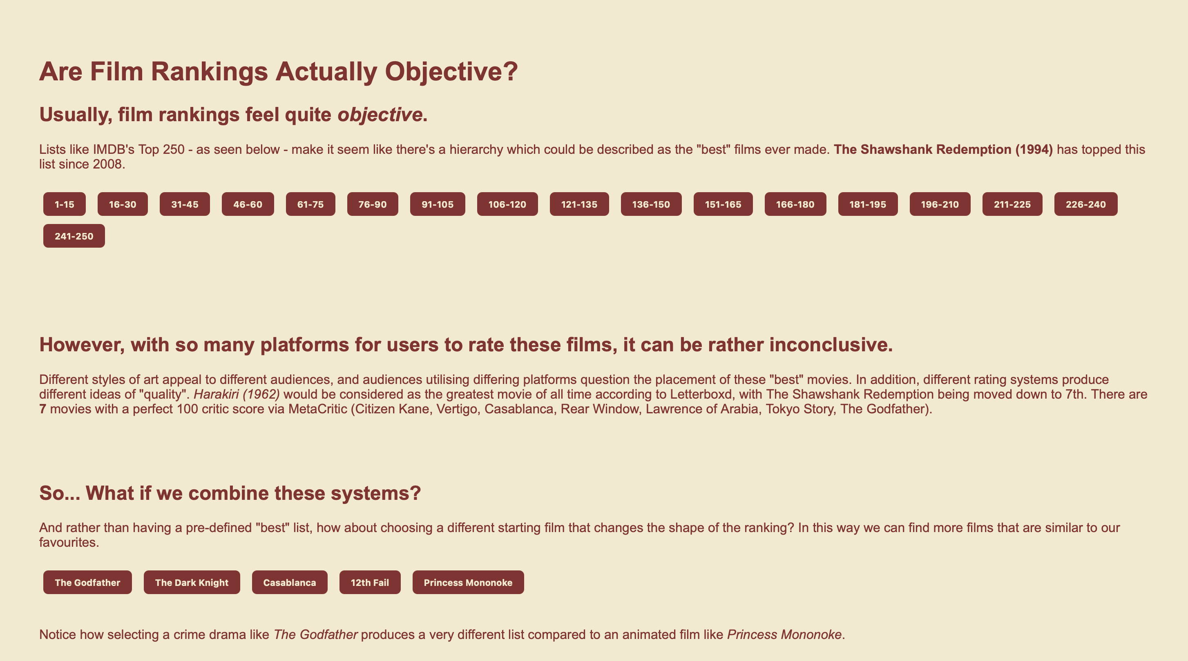
Github Repository
Website Link

Background

The initial concept for this project was inspired by the “Oracle of Bacon”, a website that allows users to discover connections between actors through their film appearances (Reynolds, 1999). My original intention was to create a similar site for movies themselves, connecting films through shared characteristics. However, I discovered that several websites already allowed users to find connections between films through actors, directors or production credits.

At the same time, I was working through IMDb’s Top 250 list and questioning some of the rankings. While films such as 12 Angry Men (1957) quickly became personal favourites, other highly ranked films did not resonate with me in the same way. This led me to question how much authority should be given to rankings that present themselves as objective measures of quality.

I also happened to read the Fizzy Mag article “Why we can’t look away from Bad Movies” (Rodgers, 2025). The article discusses how audience enjoyment is often disconnected from traditional ideas of quality, and that a film’s value cannot always be determined by critics, review aggregators or consensus rankings. This reinforced the idea that the “best” films are not always defined solely by critical acclaim or numerical ratings, but are also shaped by personal taste, cultural context and audience experience.

These observations motivated the direction of the project. Rather than treating film rankings as fixed and objective, the website explores how different rating systems construct different versions of quality. By combining data from IMDb, Letterboxd, Rotten Tomatoes and Metacritic, users can generate alternative rankings based on similarity and preference rather than popularity alone. The aim was to encourage users to question how rankings are created and to explore relationships between films that may not be visible in traditional lists.

Research

The target audience for this project is people who watch films regularly and use ranking and tracking platforms such as IMDb, Letterboxd, Rotten Tomatoes and Metacritic to discover new films. In particular, the project is aimed at users who view rankings as objective indicators of quality and assume that highly ranked films are universally considered the “best” films.

Data Sources
- IMDb Top 250 dataset
- Letterboxd ratings
- Rotten Tomato Scores
- Metacritic scores
To acquire the data for the website, I used IMDB’s Non-Commercial Datasets (IMDb.com, Inc, 1990) as the primary source. The IMDb Top 250 movies were then extracted and used as the foundation for the project. I also utilised a publicly available Letterboxd webscraper to pull Letterboxd ratings for the selected movies (r/nmcassa, 2022).

The Rotten Tomato and Metacritic scores were pulled from OMDb’s API (Fritz, 2015). API requests were made using each film’s title and associated metadata, allowing critic and audience ratings from multiple platforms to be combined into a single dataset.

Project Process & Design

Dataset creation

The data from each source (Letterboxd, IDMb, Metacritic and Rotten Tomatoes) was combined into a single CSV dataset. Ratings from different platforms use different scales (IMDb out of 10, Letterboxd out of 5, Rotten Tomatoes and Metacritic out of 100), therefore values were normalised before being used in the similarity calculation. This ensured that no single platform disproportionately influenced the final rankings.

Similarity Calculation

I developed a similarity calculation that compares films across the four rating platforms while also considering genre overlap. The system then calculated the difference between two films across the normalised IMDb, Letterboxd, Rotten Tomatoes and Metacritic scores. A genre similarity score was also introduced to reward films that shared common genres. This approach allows the system to recommend films that are similar, both statistically and thematically. For example, selecting The Godfather tends to recommend other highly rated crime dramas, while selecting Princess Mononoke produces recommendations that are closer to animation and fantasy films.

Website Structure
The website was designed around 4 core sections, exploring film rankings in different perspectives.

Into – IMDb Top 250
The first section presents the original IMDb Top 250 ranking. Films are displayed in groups, allowing users to browse the dataset and view information about individual films. This section establishes the conventional understanding of rankings before introducing alternative approaches later on in the website.
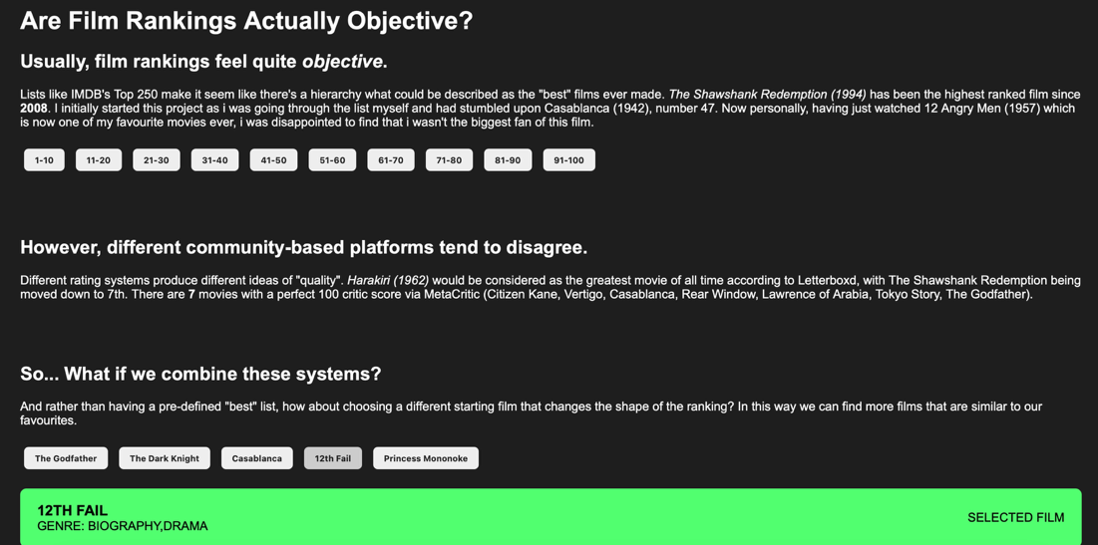

Dynamic Reranking

The second section introduces the core functionality of the project. Users can select one of several predefined films and generate a new ranking based on the original similarity calculation. Rather than asking “What are the best films?”, this section asks, “What films are most similar to this film?”. This shifts the focus from objective ranking towards personalised exploration.

Network Graph – Film Connection Network
The exploration section expands upon the reranking system by using a D3.js force-directed graph. Each node represents a film, while connections represent strong similarity relationships. Users can drag nodes, explore clusters and view recommendations through hover interactions.
This visualisation was chosen because it allows relationships to emerge organically from the dataset rather than being manually arranged. Connected films naturally cluster together through the simulation, making patterns easier to identify.Interactive features such as node dragging, hover tooltips and fullscreen viewing were added to encourage exploration.

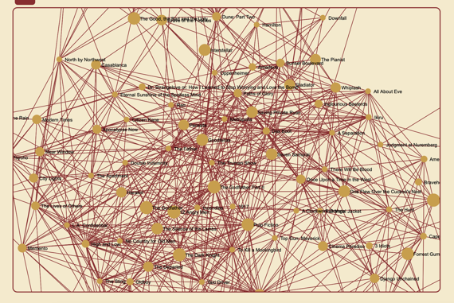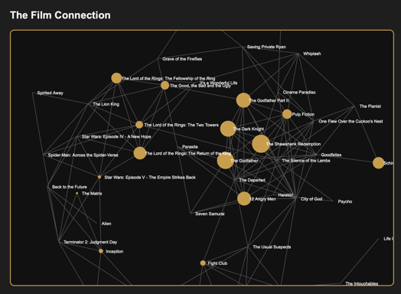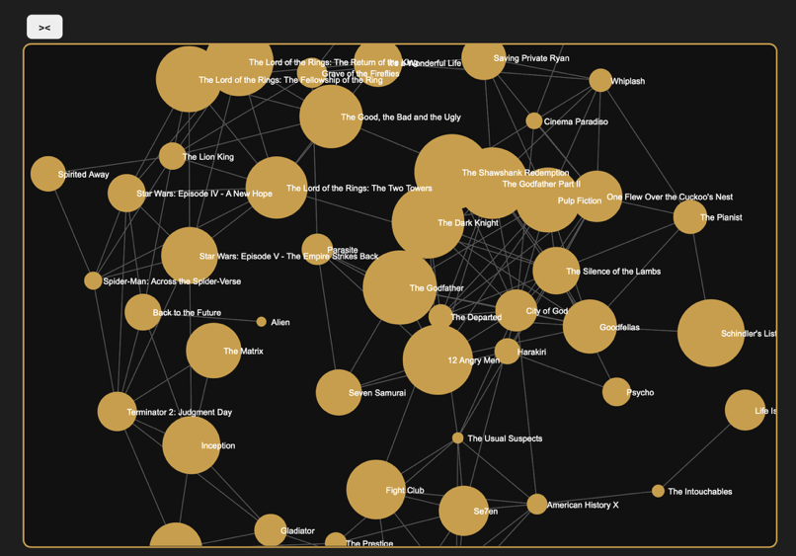

Explore – User Generated Top 10 List
The final section visualises relationships between films by allowing users to select up to three films. The similarity algorithm combines the selected films and generates a customised ranking. This feature encourages users to experiment with different combinations and demonstrates how rankings change depending on personal preferences.

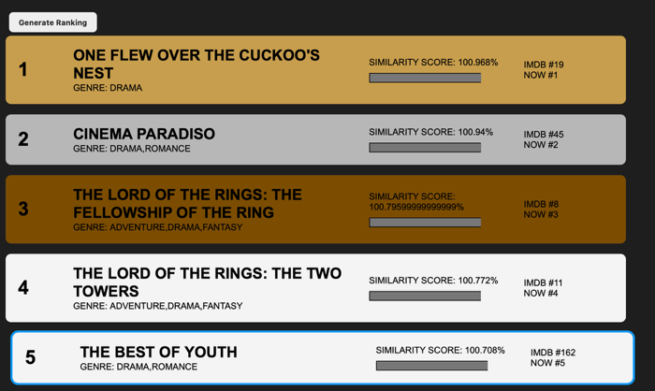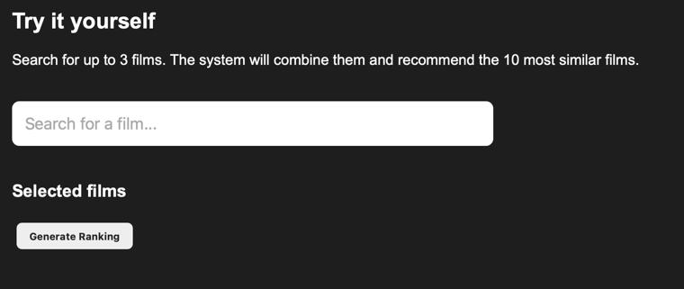

Visual Design Decisions

Film Cards
Film cards were chosen as the primary interface component because they provide a familiar way of presenting information. Each card contains a film’s title, genre, ranking position and similarity score, allowing users to quickly compare multiple films without needing to navigate away from the page. The card-based layout also supports interaction, as users can select cards to reveal additional information such as ratings from IMDb, Letterboxd, Rotten Tomatoes and Metacritic.

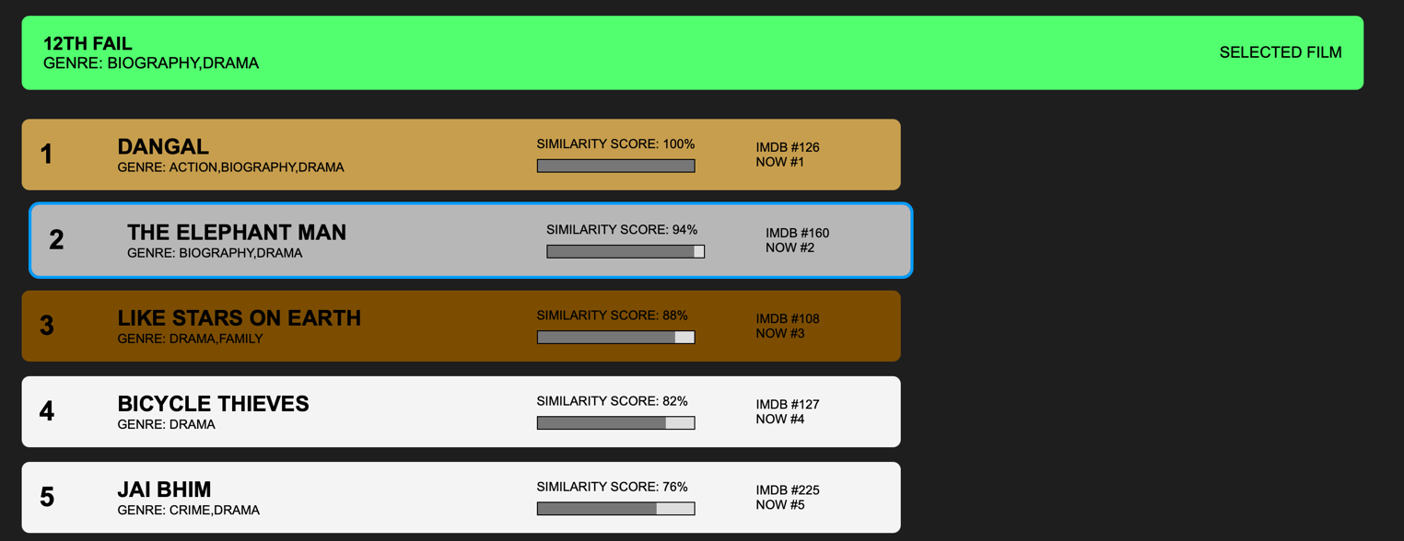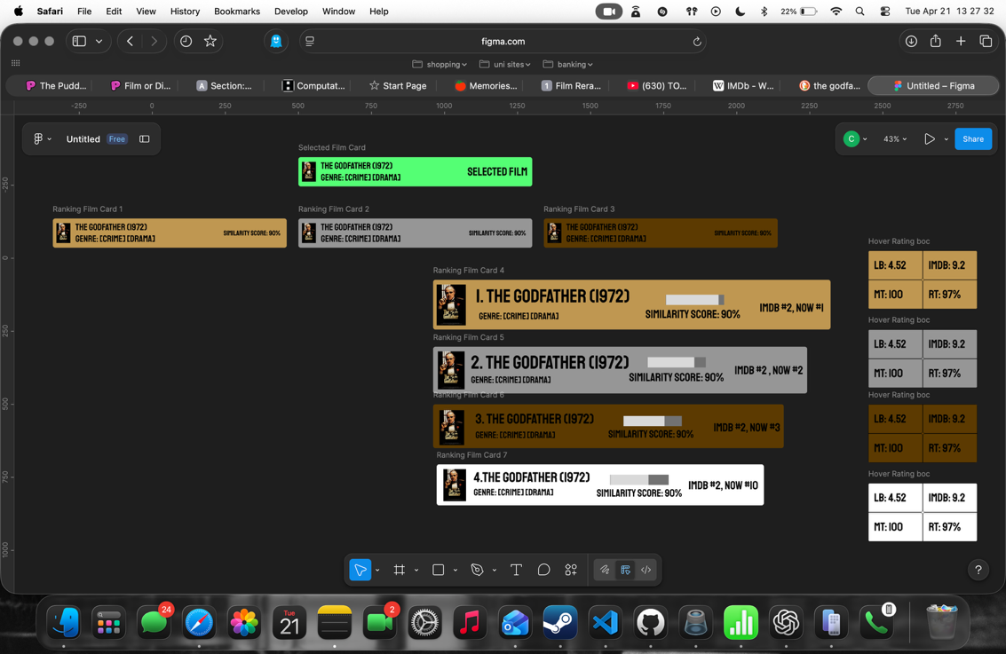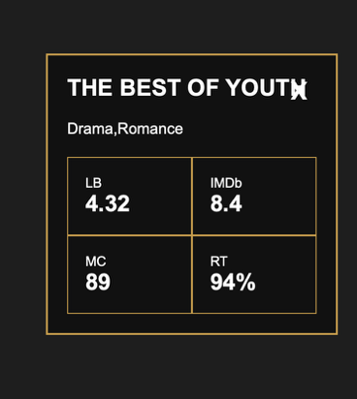

Colour Palette
I used randoma11y.com’s colour palette generator (Otander & Morse, n.d.) a tool designed to generate colour combinations that meet accessibility and contrast requirements. This was used to help ensure sufficient contrast between text, interface elements and backgrounds, improving readability and making the website more accessible to a wider range of users. By incorporating accessibility considerations into the design process, the project aimed to balance visual appeal with usability.

#872E30 : Polished Apple | #F4EACD: Yoghurt Brulee
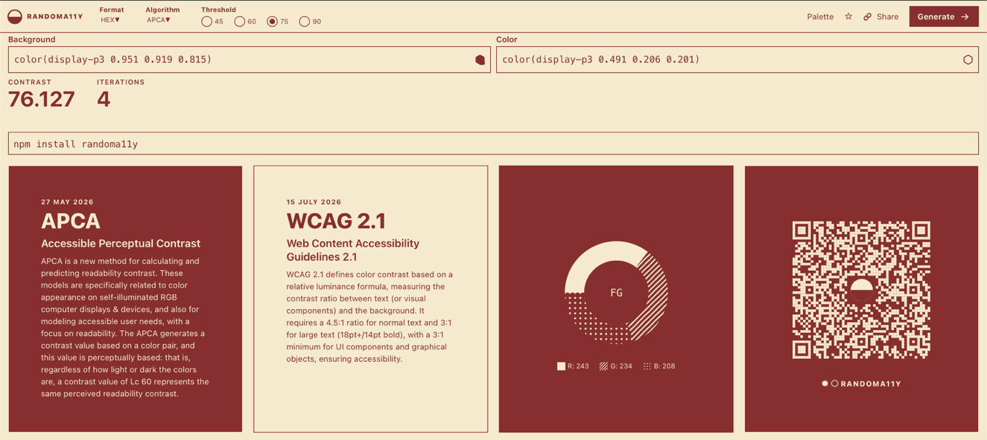

Evaluation
Overall, the Dynamic Film Reranker achieved its primary objective of encouraging users to question the objectivity of film rankings. By combining scores from leading reviewing platforms, the website showed how different evaluation systems can produce different understandings of quality. The reranking feature was effective, as selecting different films generated noticeably different recommendation lists and highlighted the influence of personal preference on rankings.
The custom exploration section also performed well, allowing users to combine up to three films and generate personalised recommendations. This provided a more interactive experience than a traditional ranking list and encouraged experimentation with the dataset. The rating panels helped users understand why films were being recommended by exposing the underlying data used within the similarity calculations.
The D3 force-directed graph was one of the most ambitious aspects of the project. It successfully visualised relationships between films and revealed clusters of similar movies that would not be obvious within a standard ranking. The addition of draggable nodes, hover tooltips and fullscreen functionality improved user engagement and transformed the graph from a static visualisation into an exploratory tool.
However, the project also had limitations. The similarity calculation is relatively simple and relies primarily on platform ratings and genre overlap. This means that some recommendations may appear similar statistically while differing significantly in narrative themes, visual style or historical context. The network graph also became increasingly cluttered as the number of displayed films increased, requiring adjustments to node size, collision detection and connection thresholds.
If the project were developed further, I would incorporate additional data such as directors, actors, release periods and user-generated tags. This would allow the similarity calculation to capture more nuanced relationships between films. I would also improve the network visualisation by implementing dynamic filtering and clustering options to make larger datasets easier to explore.

Reflection
This project provided valuable experience in combining data collection, processing, visualisation and front-end development within a single system. One of the most significant challenges was merging data from multiple sources that used different rating scales and formats. This required careful cleaning and normalisation of the dataset to ensure that comparisons between platforms remained meaningful.
The project also introduced me to D3.js and force-directed graph visualisation. Prior to this project, I had no experience using D3. Learning how force simulations, nodes, links and interactive behaviours functioned required significant experimentation and debugging. Although the final graph is relatively simple, it represents a substantial technical achievement compared to my previous web development projects.
Another challenge was balancing visual complexity with usability. As more features were added, particularly within the network visualisation, it became increasingly important to simplify interactions and reduce visual clutter. This highlighted the importance of iterative design and testing when creating interactive visualisations.
Looking back, I believe the strongest aspect of the project is its ability to encourage users to think critically about rankings rather than simply consume them. While the website presents data visually, its primary purpose is conceptual: to demonstrate that rankings are constructed systems shaped by choices, assumptions and subjective preferences. Through developing this project, I gained a deeper understanding of how data visualisation can be used not only to present information but also to challenge existing perspectives and encourage reflection.

Bibliography
Bostock, M., 2010. d3-force. [Online]
Available at: https://d3js.org/d3-force
[Accessed 10 May 2026].
Fritz, B., 2015. OMDb API. [Online]
Available at: https://www.omdbapi.com
[Accessed 24 February 2026].
IMDb.com, Inc, 1990. IMDb Non-Commercial Datasets. [Online]
Available at: https://developer.imdb.com/non-commercial-datasets/
[Accessed 24 February 2026].
Otander, J. & Morse, A., n.d. RandomA11y. [Online]
Available at: https://randoma11y.com
[Accessed 12 April 2026].
r/nmcassa, 2022. letterboxdpy. [Online]
Available at: https://github.com/nmcassa/letterboxdpy
[Accessed 24 February 2026].
Reynolds, P., 1999. The Oracle of Bacon. [Online]
Available at: https://www.oracleofbacon.org/help.php
[Accessed 24 February 2026].
Rodgers, E., 2025. Why We Can’t Look Away From Bad Movies. [Online]
Available at: https://fizzymag.com/articles/the-allure-of-bad-movies
[Accessed 13 January 2026].

